**Name :- Aditya Pandurang Takte**

**PRN:-2124UMLM2074**

**SET:-2**

**1)Veriable Details**

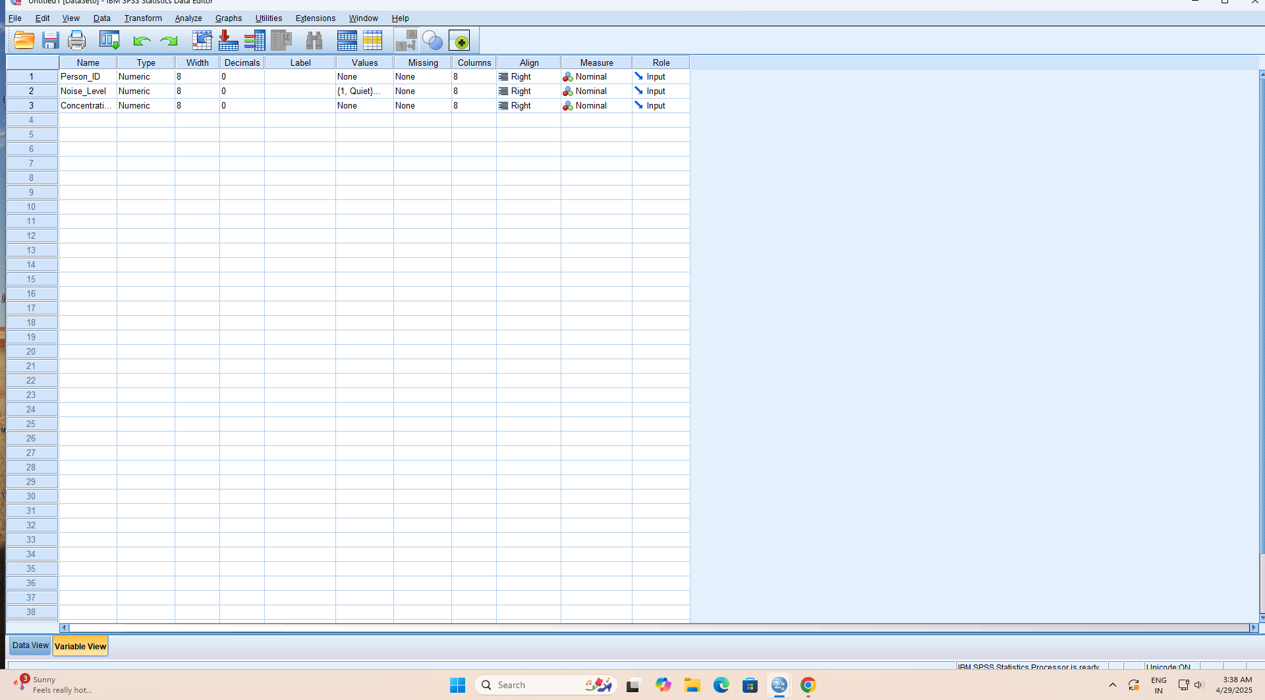

**2) Enter data**

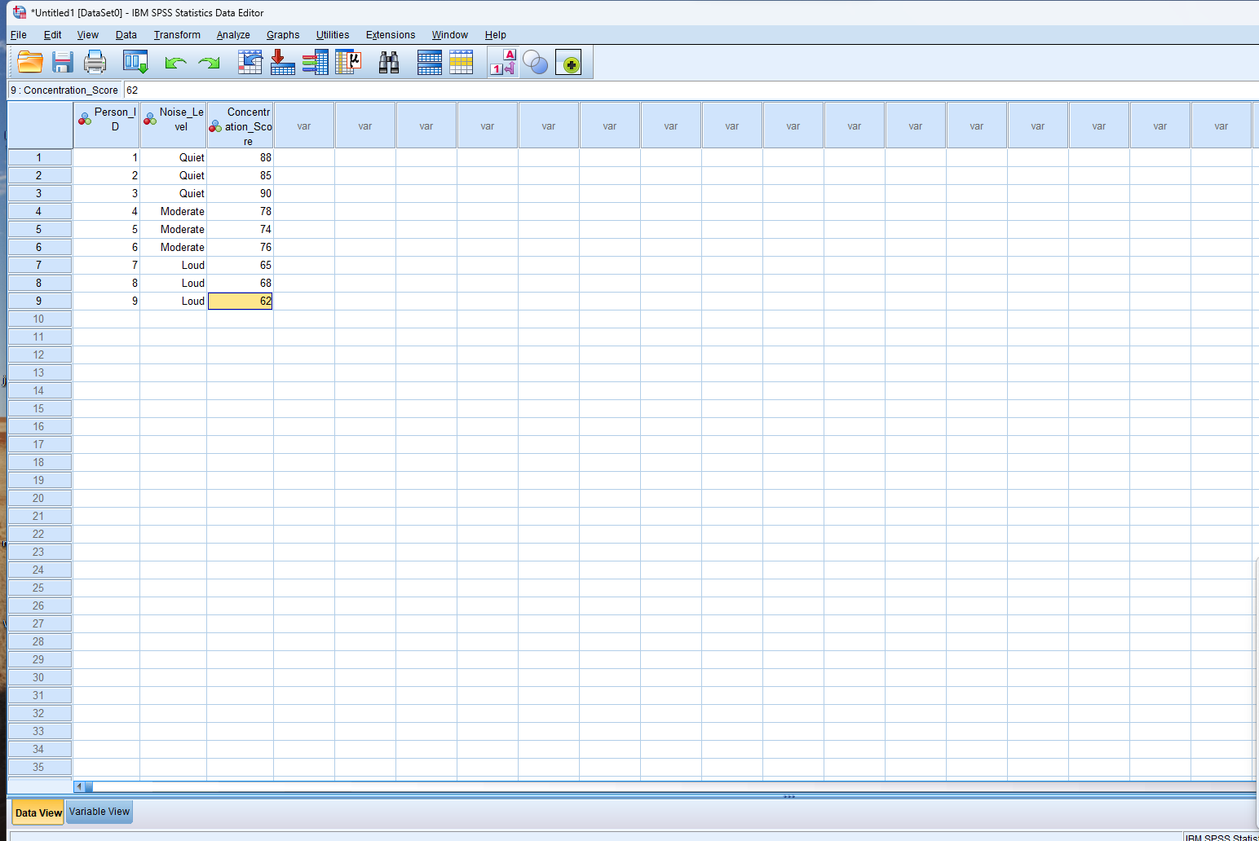

**3)Run One-Way ANOVA**

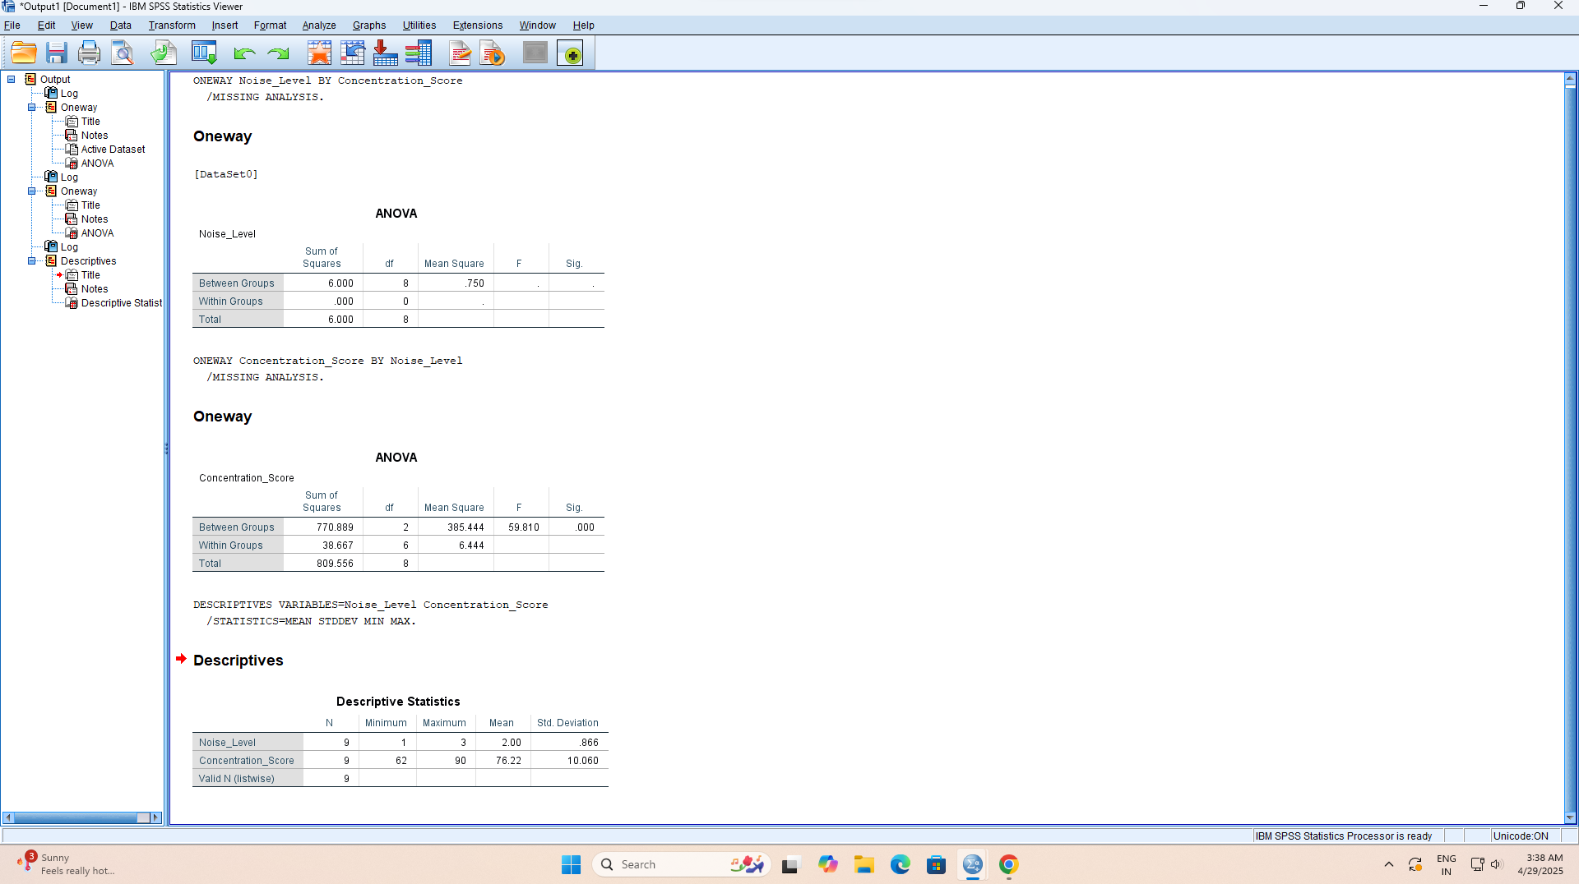

**4)Descriptive table**

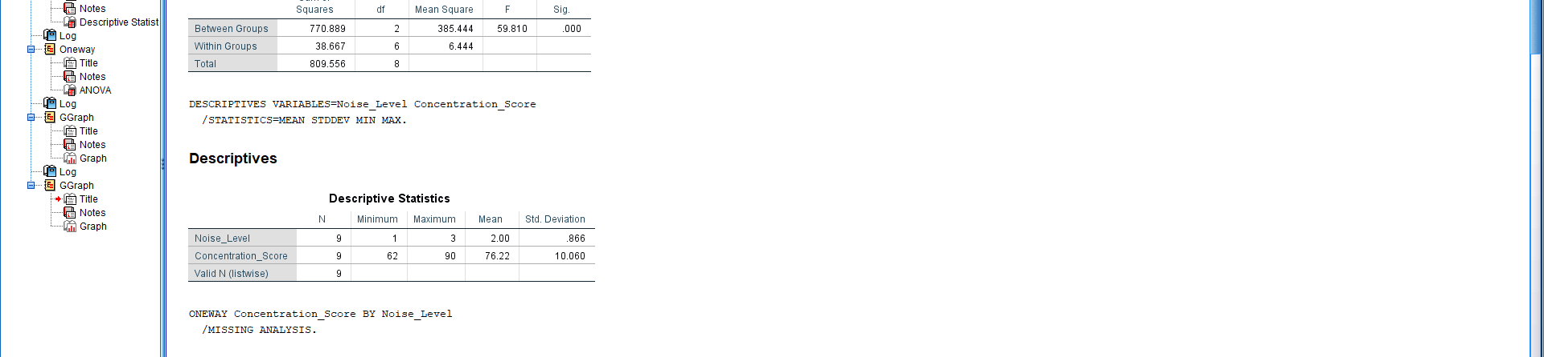

**5)Visul Bar Chart**